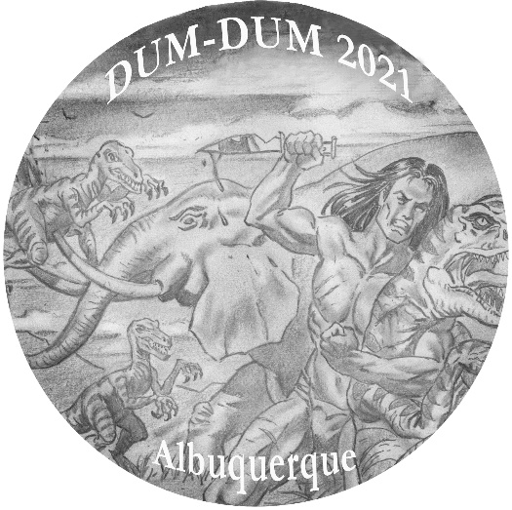
Edgar Rice Burroughs® Dum-Dum Convention 6-7 November
Holiday Inn Express & Suites ― Midtown
2500 Menaul Boulevard NE
Albuquerque, NM 87107
Direct Phone: (505) 881-0544
Room Rate $105 plus tax. Use code ERB

Convention hotel amenities include free ABQ airport shuttle 7AM-7PM, hot breakfast for registered guests, free parking, refrigerator & microwave in all rooms. All rooms are suites; handicap-accessible rooms available first floor.

Convention Registration includes color membership button & dinner at a local BBQ restaurant, authorized Tarzan® book in regular HC & free soda cans in meeting room. Presentations are in development.

Guest of Honor will be Will Murray, celebrated author of three well-received authorized Tarzan novels.

Send $125 Registration Fee for Convention via Check payable to:
Gary Buckingham 5009 Ladera Ct. NE Albuquerque, NM 87111

Limited Tables (23 total) available. Please indicate preferences below:

Name: ___________________________________________________

Address: _________________________________________________

E-mail: __________________________________________________

Convention registration quantity: ________ at $125 each = _________

Extra guest dinner only quantity: _______ at $20 each = _________

Dealer Table at no additional cost: _______ [ Yes or No ] [ Up to limit ]

