Coming Soon from ERB Inc. . . .
The Publisher’s Limited Edition
of Back to the Stone Age by Edgar Rice Burroughs™

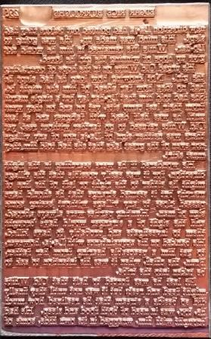

{FROM THE REAR FLAP OF THE DUST JACKET}
Recently, the printing plates for Back to the Stone Age were discovered - stored in their original wooden shipping crates. They are thought to be the only surviving set of plates for any Burroughs book. While most plates were used for as many as 30 printings, these plates were only used once – to print the first edition in 1937. Back to the Stone Age was the only pre-war Burroughs title not reprinted by either ERB Inc. or Grosset & Dunlap. That is until now.

This Publisher’s Limited Edition for Back to the Stone Age will be the first book published by ERB Inc. in almost 50 years, and their first book to feature multiple color illustrations – stunning works by some of the best ERB artists past and present. It will be printed in the same way ERB books were made 80 years ago – only better. A master printer will use the original
plates to letterpress print the text on premium paper which will be sewn and cased into a vintage-style binding. Each of the 300 books produced will be signed, numbered and covered in a dust jacket produced by Phil Normand. And most importantly, every copy of the Publisher’s edition will include one of the first edition plates used to print this edition – all housed in a custom clamshell presentation box.

The Publisher’s Edition will include:

- A First Edition Printing Plate for Back to the Stone Age:
Each Publisher’s Edition will include one copper electrotype plate used to print a page of the book. ERB production plates were used to print the first edition and then for up to 30 additional printings of a book. These plates will have only been used twice – in 1937 for the first edition & again in 2015.

- Back to the Stone Age by Edgar Rice Burroughs™, ERB Inc., Tarzana, CA. 2015.
This second edition by ERB Inc. will be printed using the first edition plates and limited to 300 signed and numbered copies.

- A Presentation Box housing both the book and the plate.
Each book and plate will be secured in a custom clamshell presentation box with gilt titles. When opened, the printer plate will be displayed in a tray on the left side across from the compartment securing the book. and the book will be secured in the compartment on the right side.
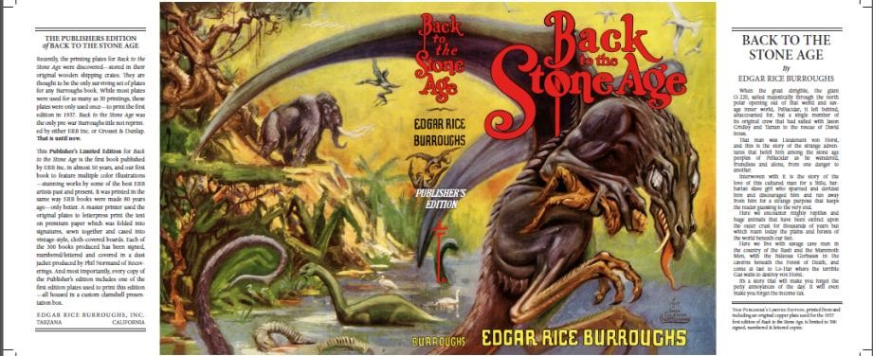
- RETAIL PRICE: $249.99 (+ $9.00 for shipping).
- ADVANCE ORDERS (before 02.01.15) Receive a 10% Discount + Free Shipping - EXPECTED SHIP DATE:
On or Before March 30, 2015

For more information go to
www.edgarriceburroughs.com or email jtgerlach@verizon.net

Trademark Edgar Rice Burroughs(TM) Owned By Edgar Rice Burroughs, Inc. And Used By Permission. Back to the Stone Age (c) 1937 Edgar Rice Burroughs Inc. All Rights Reserved.

