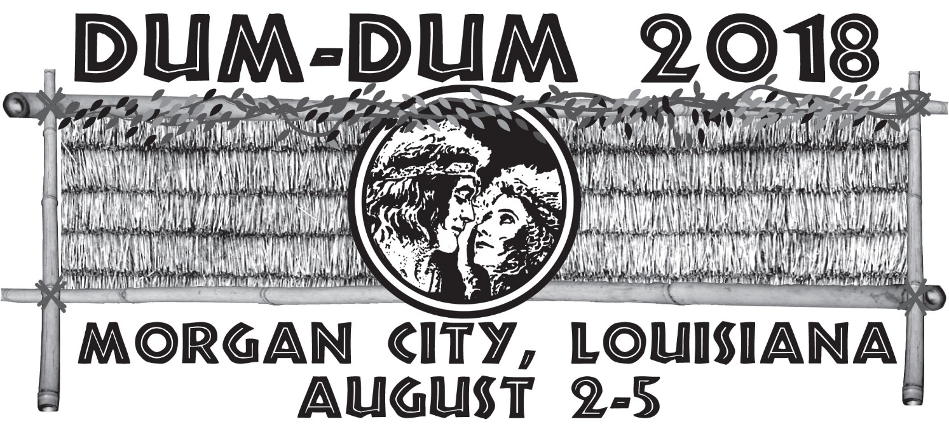
100th Anniversary of the Tarzan of the Apes 1918
Hosted by: Cajun Coast Visitors & Convention Bureau
Location: Clarion Hotel & Conference Center

Name
Address
City, State, Zip
Phone
E-mail address

Name on badge if other than above
Number of Registrations @ $105.00 each
Number of Additional Banquet Tickets @ $35.00 each
Number of Dealer Tables @ $15.00 each
Saturday, August 4 - Optional Swamp Tour Tickets @ $35.00 each: Option 1: Option 2:
King & Queen of the Louisiana Jungle Costume & Yell Contest: Number of Entries:
T-Shirts size & quantity :$20.00 S M L XL____ $25.00 XXL XXXL
Total Amount Due

Credit Card type (circle): Visa Mastercard Discover American Express
Card Number:
Name on card:
Billing Zip code:
3-digit code on back: Exp Date: Amex 4-digit code on front:

Make checks or money orders payable to: Cajun Coast Visitors & Convention Bureau
P. O. Box 2332
Morgan City, LA 70381

You may call to register by phone with credit card: (985) 380-8224

Hotel Reservations:
Clarion Hotel & Conference Center
520 Roderick Street
Morgan City, LA 70380
(985) 385-2200
www.choicehotels.com/reservations/groups/AV43V1
If calling to make reservations, please mention that you are with the Dum Dum Convention.

